CONCEPT IDEA NOTE FOR CLIMATE RELATED ACTIVITIES THAT MAY BE FUNDABLE BY THE GREEN CLIMATE FUND AND OTHER FINANCIAL SOURCES
This Concept Idea Note is based upon the GCF Concept Note. It is designed to prepare any Concepts or Project Ideas with GCF financing in mind, however, can also be applicable to other financial institutions. Once the Concept Idea Note is completed please send to the CCCI office (as the GCF National Focal Point), where an assessment will be undertaken as to whether the Concept could be eligible for funding under the GCF or other financial source, or both. CCCI will then communicate the result of the assessment back to the proponent, and outline what will next happen to the Concept Idea Note, such as require more information to make a clearer assessment, the submitted Concept is GCF eligible for funding and the next steps, or a determination that outlines the Concept is not eligible for GCF funding but may get funding from another source.
Title of Concept OR Project Idea: Aitutaki Orongo Marina Development
Date of Submission: 1 November 2018
Submitted by and Contact: Bim Tou
Indicate the areas for the Concept, which is based upon the CKI Country Program thematic areas | Mitigation: Reduced emissions from:  ☐ Energy access and power generation  ☐ Low emission transport  ☐ Buildings, cities and industries and appliances  ☐ Forestry and land use  Adaptation: Increased resilience of:  ☒ Most vulnerable people and communities  ☒ Health and well-being, and food and water security  ☒ Infrastructure and built environment  ☐ Ecosystem and ecosystem services
Indicative total project cost | Amount: NZD $15.4 mil
Project/Programme rationale, objectives and approach of programme/project (max 100 words)
Brief summary of the problem statement and climate rationale, objective and selected implementation approach, including the executing entity(ies) and other implementing partners.

Problem Statement

The current channel that is used to access the port was originally created by a fresh water stream and was subsequently modified by the US military during the Second World War.
The current channel is however too narrow and has insufficient depth to act as a viable port for international yachts and international cargo vessels. Current cruise ship tender transfer of maximum passenger transfers to shore is reduced due to the channel depth restrictions for tenders to safely and comfortably transport passengers between the ship and the port.

Cargo ships are unloaded outside the reef with freight transferred to the wharf on a single self-propelled barge. Conditions are sometimes too rough to unload and/or cause damage to containers and freight. Ships are required to stay in the roadstead for 2-3 days for unloading. This could be reduced to one day by a combination of channel improvements and/or additional barges.

Aitutaki is well situated for Pacific yacht cruisers, particularly those on the Panama – Vava’u (Tonga) run to NZ or when circumnavigating, via Galapagos, Marquesas, Tuamotus and Tahiti / Bora Bora. A number of cruisers head towards Suwarrow in the Northern Cooks but there are no services there.

The Aitutaki Orongo Development project has been jointly developed by the Aitutaki community and the Cook Islands Government and involves the development of:
- A Town plan
- The Orongo community centre
- The Harbour
- The Marina
- A Tourism centre/office

The project has two main components:

- Element 1:
  - A deepening and widening of the existing channel to allow yachts, cruise ship tenders and domestic ships to safely berth in the harbour.
- Element 2:
  - In addition to element 1, developing a marina area for increased tourism earnings, with a focus on sports fishing, tours of the lagoon and visiting yacht cruisers.
  - Upgrading the island centre to create a commercial hub and community and visitor amenities.

Aitutaki is dependent on the lagoon for local livelihoods, community wellbeing (including cultural activities) and sustaining tourism. Given the significant conservation value of the lagoon (which for the most part is untouched), any solution has to ensure the continued health of the lagoon.

The Cook Islands continues to experience tourism growth predominantly in Rarotonga and Aitutaki. Based on increased airline access and improved tourism infrastructure the Government is seeking to develop the Cook Islands as a sustainable and appealing tourism destination delivering long term economic value to the government and the community. A key component of the tourism growth strategy is to support the overall development of Aitutaki as a second destination by upgrading its key natural attractions and public infrastructure facilities.

The Aitutaki Orongo Development project is considered likely to be attractive to international aid donors because it:
- Has a strong economic development focus
- Is a critical lifeline infrastructure, mitigates the adverse impact of climate change on the port infrastructure and it utilises existing port infrastructure.

Supports a viable community that is achieving population growth and is already experienced in meeting the needs of high value tourists

A concept drawing of the water side of the development is shown below:
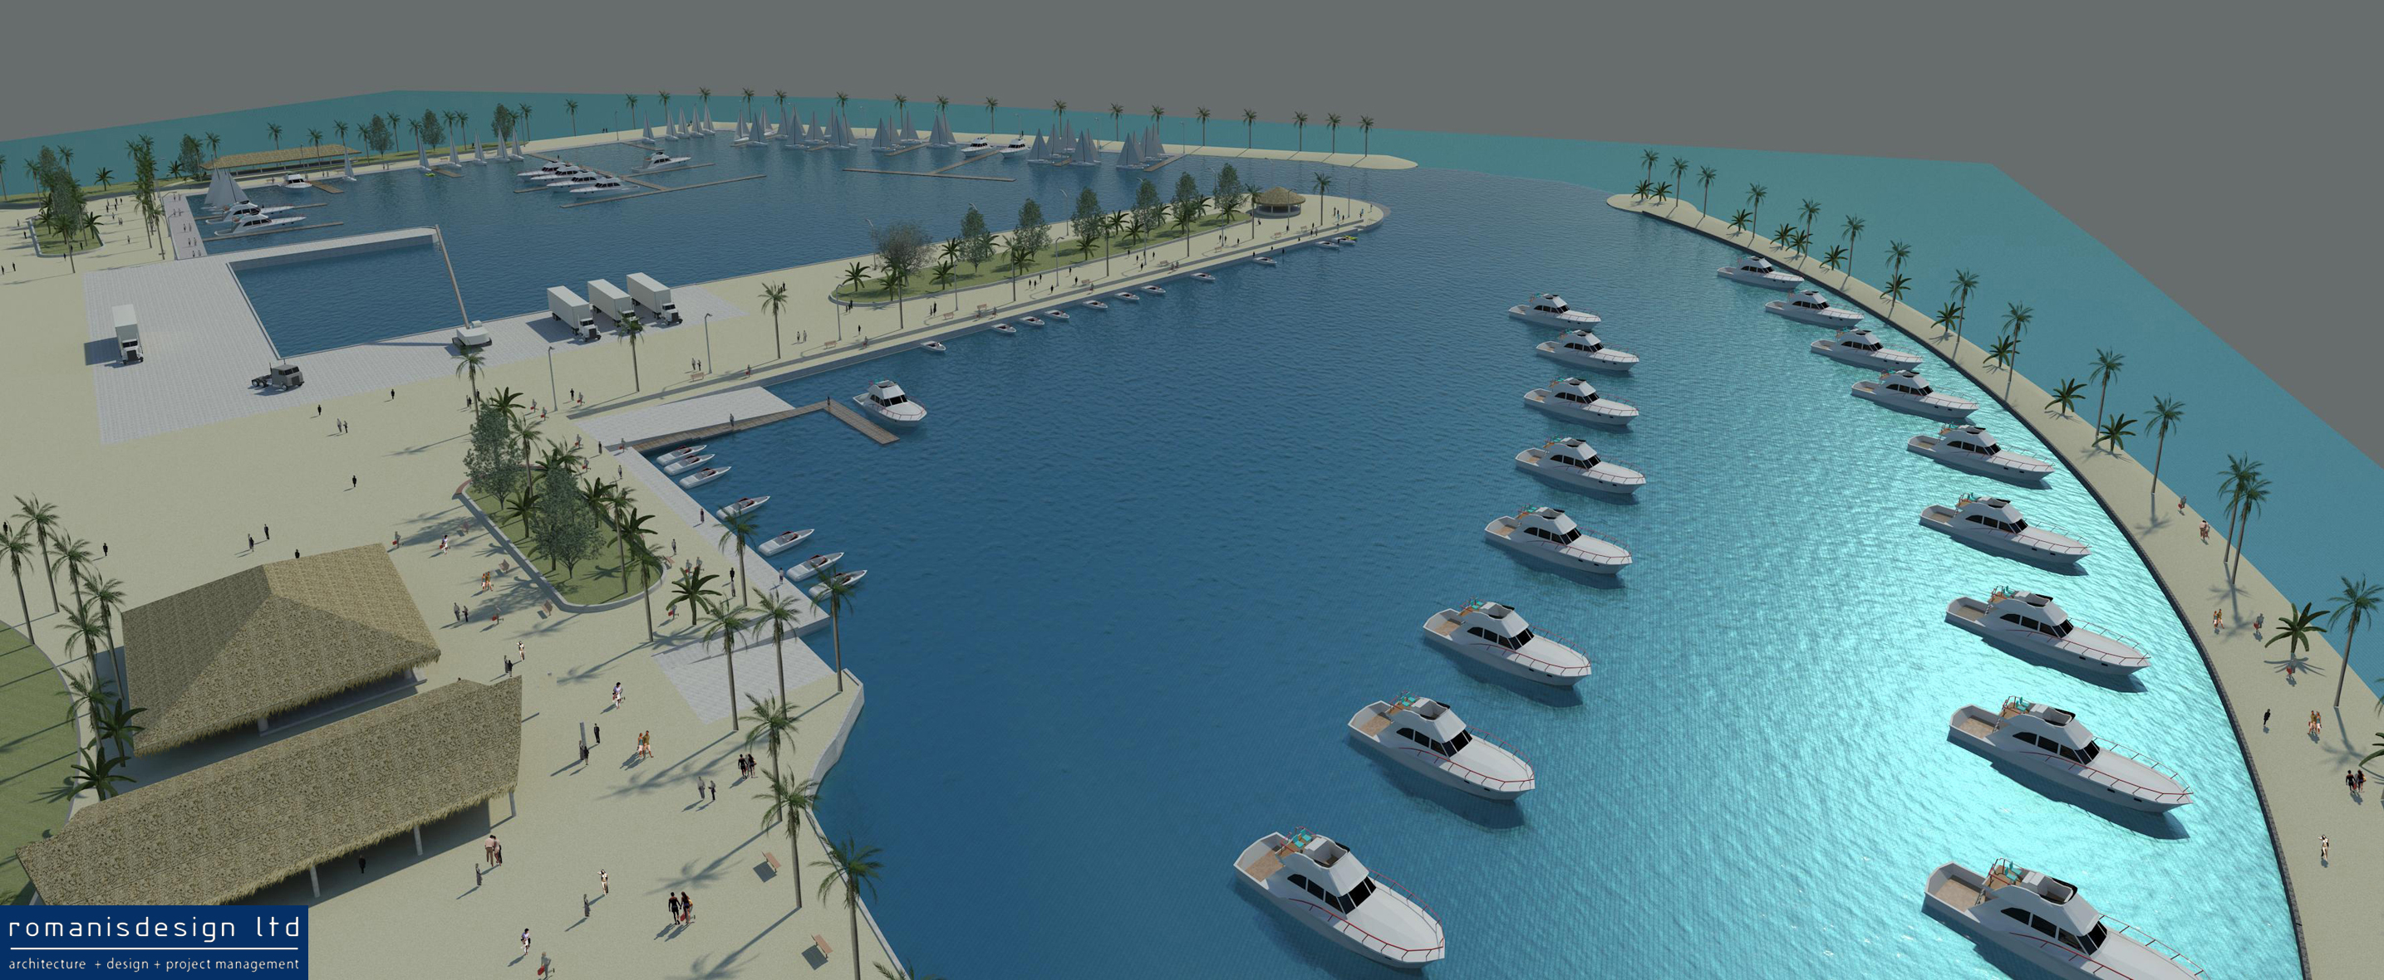
Northern Marina Conceptual Drawings

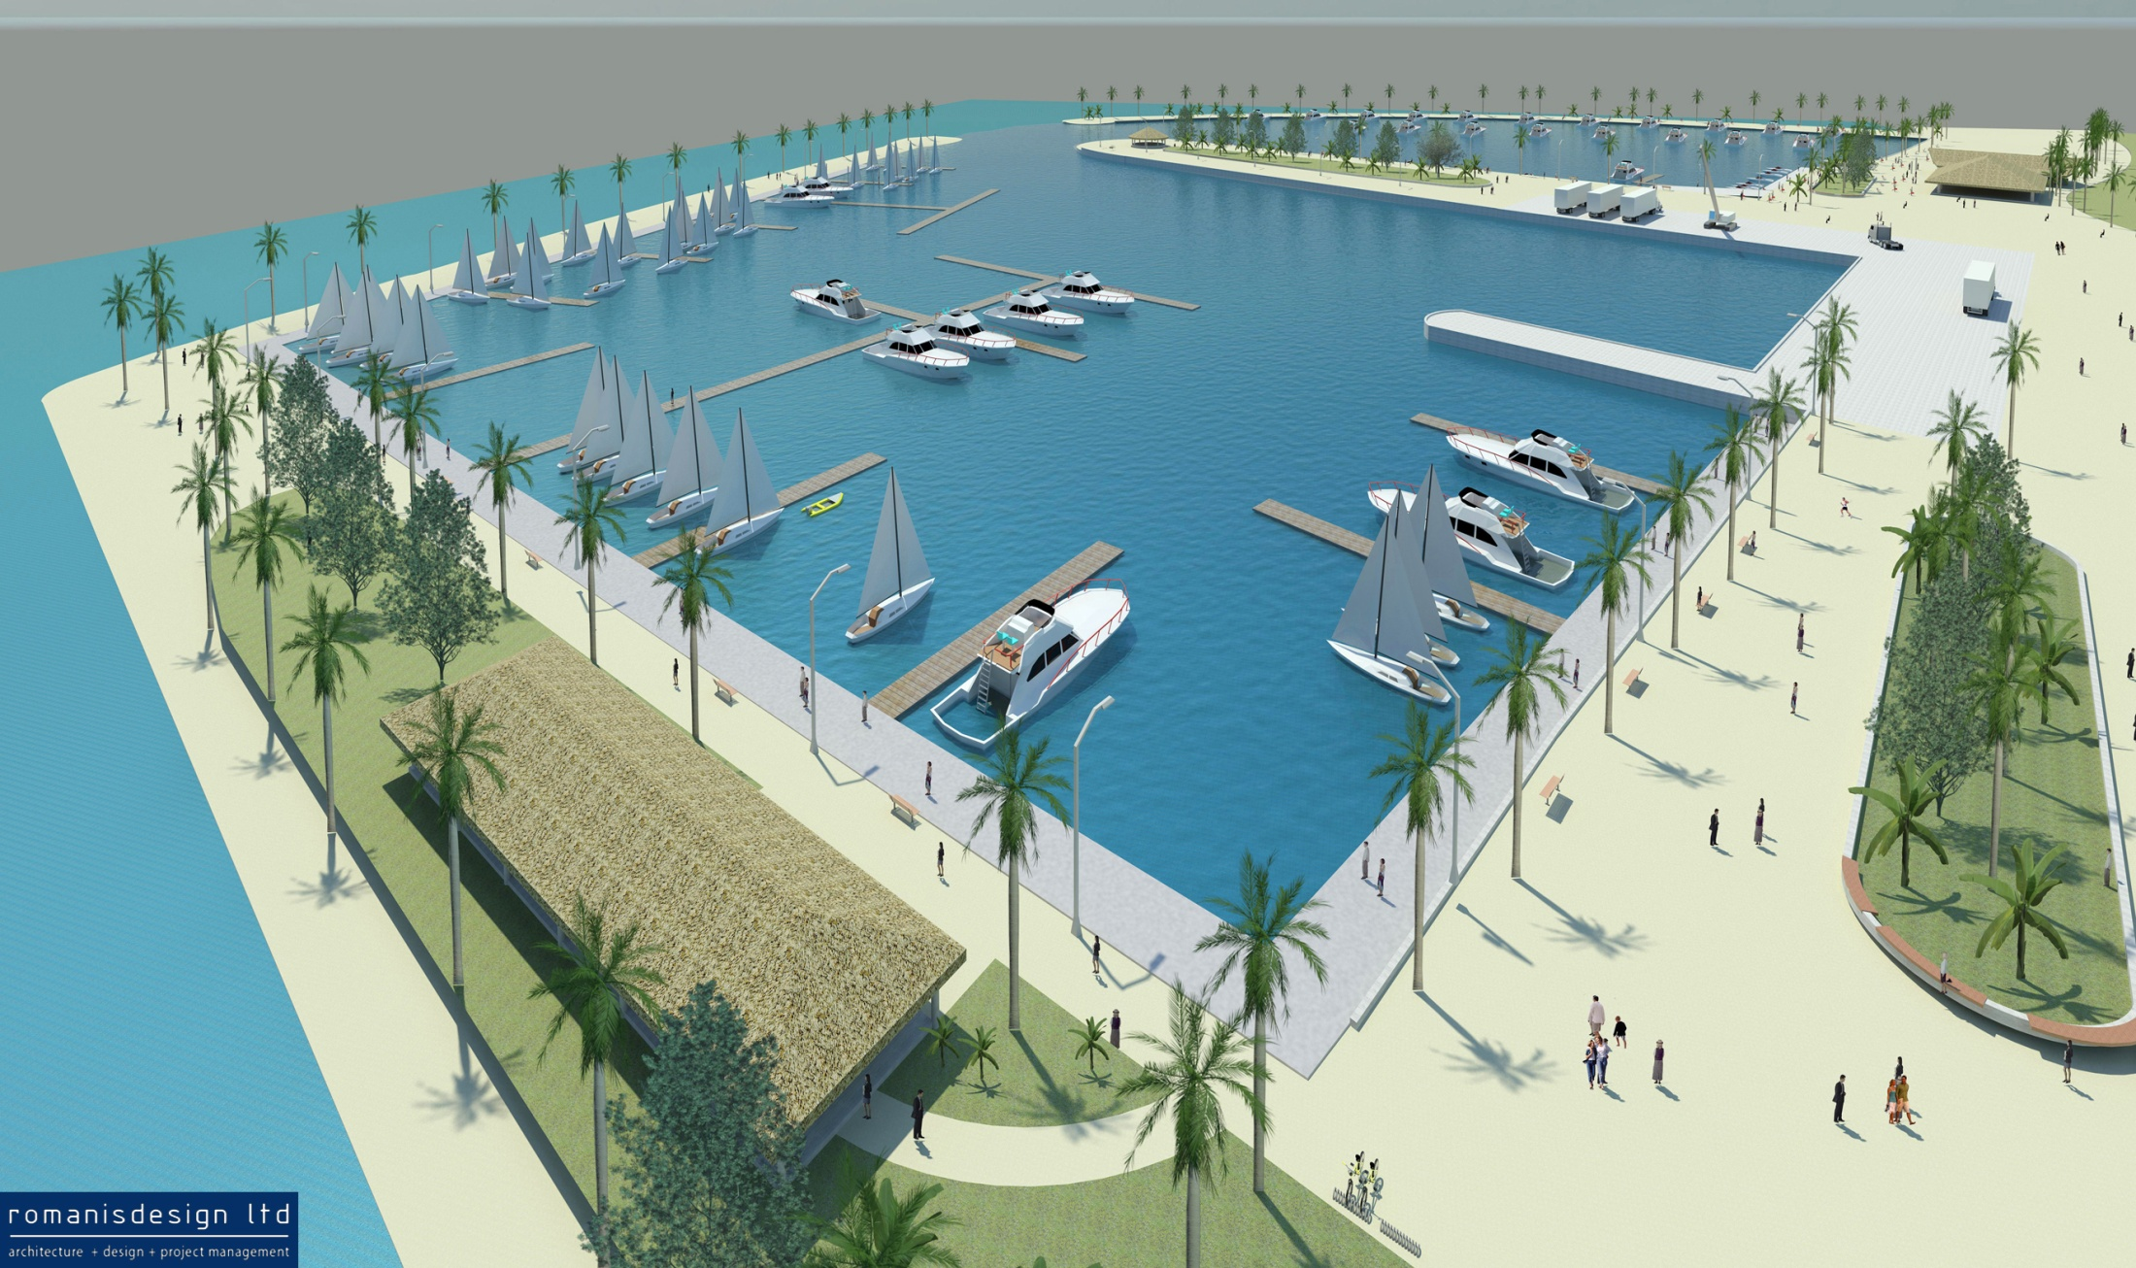
Southern Marina Conceptual Drawings

On the basis of a capital construction cost of approximately $15.4m, it covers:

- Dredging works to safely allow yachts, cruise ship tenders and small ships into the harbour;
- Renewal of the wharf infrastructure where condition is poor, including infilling a silted-up part of the basin to create more cargo handling space;
- Structural works at the port to improve resistance against the effects of sea level rise caused by climate change; and
- Tourism-focused development of the port and marina.

Context and baseline (max. 2 pages)
Describe the climate vulnerabilities and impacts, GHG emissions profile, and mitigation and adaptation needs that the prospective intervention is envisaged to address.

Studies and observations have identified that changes in climate for the Cook Islands are manifesting in an increase in extreme events such as storm surge, floods, and cyclones. This is of significant national concern. The importance of better understanding of the risks associated with these extreme events on vulnerable national infrastructure and communities cannot be over emphasized in order to plan and prepare for current and future changes.

The existing geographical vulnerability of the country to climate change can be improved by enhancing the country’s adaptive capacity and resilience to climate change, including the impacts of extreme events. Incorporating climate change adaptation strategies into social and infrastructure programs will also strengthen capacity to avoid and manage disasters.

Recent years have seen an increase in both frequency and - of most concern - intensity of extreme climate events.

And in order to prevent proposed marina development and Arutanga Port rehabilitation from extreme climate events, the project proposal “climate proofing” needs addressing by constructing the breakwater to the northern and southern marina; mitigating associated climate risks measures by strengthening resilience to climate extreme events, improve food security resilience and social and economic resilience to the yacht marina users, Arutanga Ports plus associated tourism related businesses and community.

Please indicate how the project fits in with the country’s national priorities and its full ownership of the concept. Is the project/programme directly contributing to the country’s INDC/NDC or national climate strategies or other plans such as NAMAs, NAPs or equivalent? If so, please describe which priorities identified in these documents the proposed project is aiming to address and/or improve.

National Priorities

The specific objectives of the proposed Project include:

- Stimulating greater economic development from tourism;
- Diversifying into new and growing tourism market segments, including those who travel by international yachts and passenger cruise ships;
- Providing safer mooring and improved launching facilities;
- Improving the amenity of the public space adjacent to the harbour;
- Maintaining the current environmental health of the Arutanga harbour; and
- Strengthening the lifeline shipping services to the island by improving access for lighters bringing cargo into the port plus cruise ship tenders.

Without this Project, there will be no economic benefit from increased cruising yacht visits and no improvement to access for the lighters which transport supplies from cargo ships to the harbour plus cruise ship tenders.

As highlighted under the CLIMAP report, as with most Pacific island states, the Cook Islands’ infrastructure is ill prepared against climate-related vulnerability. The Pacific Adaptation to Climate Change (PACC) consultations noted that the geographical vulnerability of the country to climate change can be improved by initiating integrated infrastructure and social development.

Consequently, a need for ‘climate proofing’ the country was identified, that is, for enhancing the country’s adaptive capacity and resilience to climate change, including the impacts of extreme events. The PACC report further noted that strengthening disaster management and mitigation capacity will help to ensure that future maritime infrastructure development will incorporate climate change adaptation and mitigation measures.

The Cook Islands National Sustainable Development Plan (NSDP) highlighted the importance of climate risk proofing, in particular for the Goal of “a safe secure and resilient community”. The National Climate Change Country Team identified coastal zone management and associated infrastructure to be a priority for adaptation intervention in the Cook Islands. This was further reinforced by the National Environment Strategic Action Framework (NESAF) Review and consultations for NESAF 2011-2014. The CIG is advancing with Joint Disaster Risk Management Climate Change National Action Plan and Policy development which aims to maximize the Cook Islands limited institutional capacity in mainstreaming both climate change and disaster risk management across all sectors to increase community resilience.

Consequently, the priority programme areas for this project are:

Programmatic Area 2: Coastal Protection and Restoration

As low lying islands, the entire Cook Islands is vulnerable to sea surges, sea level rise and extreme weather events. Communities have been experiencing over many years land loss, as shorelines recede into the sea, damaging infrastructure, housing, and natural habitats. This in turn results in other detrimental impacts such as salt water inundation of planting areas, threatening food security and livelihoods, increase in vector borne disease and so forth. Consultations with communities have indicated that the problem is being exacerbated by the rising tides and more frequent sea surges caused by climate change. Coastal protection and restoration is essential for building resilience of both built and natural environments and for maintaining the livelihoods of communities.

Programmatic Area 4: Disaster Risk Management

The Cook Islands by virtue of its geography is extremely vulnerable to disasters and extreme climate events. While the country has in place legislative and institutional structures to enable preparedness, response and recovery, national funding for adequate preparedness is insufficient. With the lives of people at risk during disasters and extreme climate events, and the prediction that extreme events will intensify with climate change, further investment is required to build resilience and safeguard lives.

Programmatic Area 6: Climate Proofing Infrastructure

As all islands are vulnerable to impacts of climate change, including more severe extreme weather events, sea surges and sea level rise. It is essential that key public, private sector and domestic infrastructure are not only protected, but also constructed and developed in a manner that takes into account the mentioned impacts. Priority infrastructure requiring climate proofing are ports, airports and buildings.

With the exception of Rarotonga, current harbours in the outer islands require ships to moor offshore for unloading and loading of cargo and passengers. Handling of cargo and passengers is a challenge and can be dangerous, particularly when the weather conditions are not ideal. Harbour facilities, therefore need to take into consideration the predicted worsening climate impacts. Additionally, when boats are unable to offload cargo and passengers, they drift until the weather clears, burning fuel. Improvement of harbours is also thus, a means of reducing emissions by limiting drift time for boats. Consideration should also be given to the possibility to ensure quick evacuation and safety during time of disaster.

Future infrastructure development in all islands should incorporate climate proofing in design and construction. This will equate to increased costs, which is an additional burden on either government, the private sector or homeowners depending on the development project. The private sector and individuals require some assistance such as cheaper financing options to incentivize climate proofing infrastructure.

Overall climate proofing will ensure that infrastructure will be able to withstand the impacts of climate change, maintain connectivity, enable economic activity and build the resilience of livelihoods, people and communities.

Programmatic Area 10: Building Resilient Livelihoods of People and Communities

The Cook Islands and peoples are extremely vulnerable to the impacts of climate change and the socio-economic, infrastructure and environment pressures intensifies this vulnerability. The key characteristics of building resilience in the Cook Islands context is to ensure that the government, private sector, communities and households have the ability to adapt to changes, anticipate what might happen next and absorb shocks when they do come along. With more frequent dry periods, stronger storms, creeping sea level rise, changes in agriculture productivity and the marine environment, it is essential that families, communities and the private sector can manage and improve their ability to bounce back. It is important to build the adaptive capacity to reduce the impact of future hazards.

During private sector and community consultations for the development of the Green Climate Fund Country Programme, people have indicated that one of the hindrances to building their resilience to climate change as well as investing in mitigation is the lack of and cost of funding. Funding availability either through grants, cheaper financing and enabling policies such as tax breaks will assist people to build resilience.

Describe the main root causes and barriers (social, gender, fiscal, regulatory, technological, financial, ecological, institutional, etc.) that need to be addressed.

Based on discussions with the Island Council and Aronga Mana representatives, we received strong endorsement for the development. Their main interest is in the landside development of the island centre.

Concerns about the environment, in particular the health of the lagoon were raised and were reassured that environmental issues are recognised at the fore of this development.

The main root causes and barriers for the proposed project are social, fiscal, financial, and environmental, and these can be addressed with the incorporation of the community environment concern into the EIA.

The combination of port infrastructure in poor condition and sea level rise caused by climate change represents a significant risk to the Ports Authority in the medium term. While mobilising to improve the channel and creating a large amount of spoil, it seems prudent to combine the construction of the landside infrastructure with the channel works. Splitting the projects into two elements would mean that the significant mobilisation costs would be incurred twice, as well as the challenge of creating an interim dump site.

Given the geography of the environment, any infrastructure will be at risk of significant loss in a cyclone. The major part of this project however, is the upgrading of the channel which is unlikely to have any impact as dredging works will stop during extreme event conditions.

Where relevant, and particularly for private sector project/programme, please describe the key characteristics and dynamics of the sector or market in which the project/programme will operate.

The overall objective of the Orongo Development Project is to provide secure and efficient harbour infrastructure in Aitutaki and an enhanced community space. This will contribute to continued economic growth and improved well-being of the population.

The specific objectives of the proposed project include:

- Stimulating greater economic development from tourism;
- Diversifying into new and growing tourism market segments including those who travel by international yachts and passenger cruise ships;
- Providing safer mooring facilities;
- Improving the amenity of the public space adjacent to the harbour;
- Maintaining the current health of the Arutanga harbour; and
- Strengthening the lifeline shipping services by improving access for lighters bringing cargo into the port plus the cruise ship tenders.

The Cook Islands Government has a stated goal of achieving tourism growth based on increased airline access and improved tourism infrastructure and to be sustainable and appealing tourism destination delivering long term economic value to the businesses and the community.

Engagement among the NDA, AE, and/or other relevant stakeholders in the country (max ½ page)
Please describe how engagement among the NDA, AE and/or other relevant stakeholders in the country has taken place and what further engagement will be undertaken as the concept is developed into a funding proposal.

Past discussion held with Donor Partner New Zealand has expressed interest to assist with aid funding, but other competing committed NZAID country priorities takes precedence. Public Private Partnership (PPP) financing also explored without interest shown.

Ports Authority is unable to entertain any borrowings at this time due to the Avatiu Port Redevelopment borrowing commitment to the Asian Development Bank (ADB) currently outstanding at NZ$21.3 mil.

Sustainability and replicability of the project (exit strategy) (max. 1 page)
Please explain how the project/programme sustainability will be ensured in the long run and how this will be monitored, after the project/programme is implemented with support from the GCF and other sources.

The key elements of the Orongo Development Project are:

- Deepening of the existing entrance channel from 2-3m deep to 6m deep.
- Widening the existing harbour entrance channel from 10m to 15m.
- Dredging of 40 – 60,000 m3 of material to deepen the existing mooring basin at the north of the existing causeway for visiting yachts.
- Construction of an approximately 200m long and 8m wide breakwater to the north of the northern basin
- Dredging of 70-80,000 m3 of material to deepen the existing mooring basin to the south of the existing causeway, including approximately 30,000 m3 of material from the port basin to accommodate deeper draft vessels.
- Realignment and reconstruction of a 150m long and 8m wide breakwater on the southern side of the southern basin.

The future construction of a community facility adjacent to the port, which will include:
- Multi-purpose market and cultural area;
- Adjacent toilets; and
- Island Council offices, and.
- The future reconstruction of wharf facilities, including new sheet piles and hardstand.

The impact of the Project will be climate proofing the north and southern marina from extreme climate events such as, sea level rises, sea surges and increase social and economic well-being of the local and business community. The Project aligns with government policy outlined in the NSDP.

The Project addresses the following strategic goals of the NSDP:
- an innovative and well-managed private sector-led economy;
- Strengthened and affordable basic infrastructure, transport, and utilities to support national development.

By safeguarding Arutanga Harbour and the Marina and should GCF and other Donor Partners express the appetite for funding, the project will ensure that facilities required for private sector-led economic growth are strengthened and associated risks from operational efficiency and extreme climate events are removed.

For non-grant instruments, explain how the capital invested will be repaid and over what duration of time.

As reported; Ports Authority is unable to entertain any commercial borrowings at the local banks to finance capital investment of the project that does not qualify for grant assistance at this time due to the Avatiu Port Redevelopment borrowing commitment to the Asian Development Bank (ADB) currently outstanding at NZ$21.3 mil.
However, any concessional financing available from Development Partners could deliver the project depending on the concessional terms and financing cost. This could be serviced from Arutanga Ports existing plus expanded improved efficient port operations, and the potential revenue from the marina due to the potential increase in yacht and cruise ship calls.

Benefit analysis
The main driver of benefits arising from the development of the port and marina is growth in the sale of goods and services to tourists. The key factors that influence the increase in the sale of goods and services are:
- The increase in the number of international yachts. It is estimated that approximately 1000 yachts currently by pass Aitutaki each year and the number of international yachts in the region is forecast to continue to grow. For modelling purposes it has been assumed that:
  - In the first year an additional 100 international yachts will visit Aitutaki and that this will steady grow to 1000 over 10 years.
  - The average length of stay for these yachts is five nights.
  - The average spend on food and beverages per passenger per day are $15 growing to $25 over ten years.
  - The average sales by local stallholders will be $25 per passenger.

- The increase in international cruise ship visits. For modelling purposes it has been assumed that:
  - In the first year an additional three visits will occur and this will increase to 10 visits each year over the next 10 ten years.
  - An average of 300 passengers will disembark and visit Aitutaki during each trip
  - The average spend for food and beverages per passenger will be $25 and on average they will undertake at least one tour with an average price to the operator of $75.
  - The average sales by local stallholders will be $25 per passengers

- The benefits arising for the port from improved freight handling and introduction of coastal traders to berth at the harbour. The key factors that influence the benefits from improved freight handling are:
  - A better competitive market for freight because of smaller cargo vessels being better placed to compete with the larger international freight companies.
  - The dredging of a total of 100,000 to 310,000 cubic metres of mud, sand and coral that can be used as aggregate.

In addition, yacht mooring charges will contribute to the increase in port revenue.

Noted also that there are significant net economic benefits to be gained from undertaking the port and marina development. However given the majority of the benefits will accrue to small businesses and individuals, it is unlikely that such a development could be privately financed.

Assessed By and Date:

Bim Tou 1st November 2018

Recommendation:

For your favorable consideration

